*Celebrating a Book Launch from one of our own….*

Only $20 per copy

+ $5 Postage in New Zealand

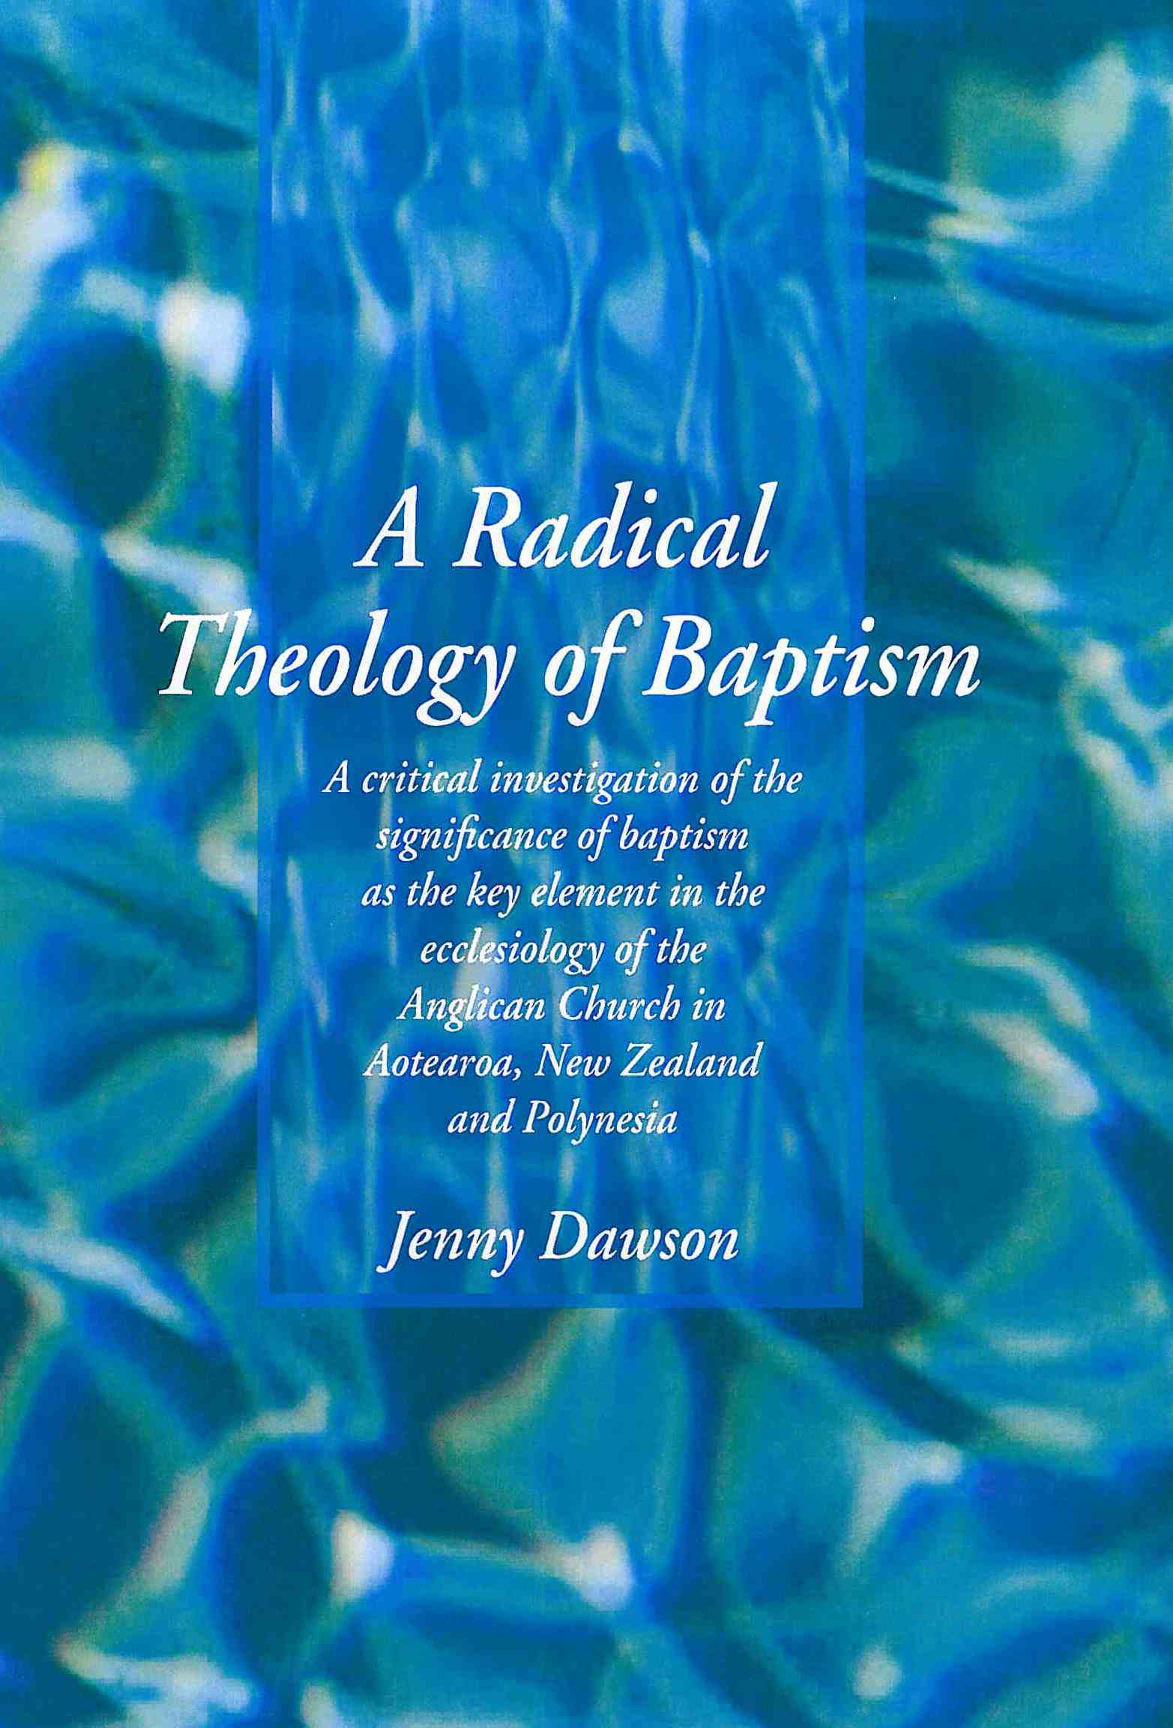

You can order your copy now directly through

**jenniferdawson@xtra.co.nz**

Or contact the Anglican Resource Centre in Wellington on

**resources@wn.ang.org.nz**

“Reflection through her own experience brings to life the intricacies of what baptism means in people’s lives, impacting in their local faith community, Whanau, society or international settings. Jenny recognises its implications and power for living the Gospel to right injustices and empower both lay and ordained, especially through Local Shared Ministry’s emphasis on team relationship, grounded in local concerns, and working together being at the heart of God.”

*Jenny Campbell, LSM Enabler for Te Anau, member of the Anglican Social Justice Commission and Women’s Studies Centre Link Representative for the Diocese of Dunedin*